Lab Assignment 11
Stepan Shkrobak
Dr. Michael Bartolacci
IST 894, Section 001: Capstone Experience,
12 April 2026

Table of Contents

Table of Contents 1
General Context 2
Technical Context 3
Screenshots 5
References 6

General Context
The Cybersecurity senior management and information security governance (ISG) course emphasizes that effective cybersecurity begins with senior leadership establishing clear direction and oversight for security activities. Governance provides the structure through which an organization can define its security mission, establish policies, set strategic priorities, and align cybersecurity efforts with overall business objectives. Executives and senior managers, as a result, play a significant role in determining how security programs are implemented, funded, and monitored, as a lack of this support may result in a weak organizational cybersecurity stance (NIST, 2024; ISACA, 2023).
The course also covers the importance of defining leadership roles and coordinating oversight. Chief Information Security Officers (CISOs) or Information Security Officers (ISSOs) are roles, for example, that serve as bridges between executive and technical teams, allowing for better communication as well as ensuring security strategies, risk management practices, and compliance efforts all align with business objectives. Depending on the size of an organization, the roles may vary, but the need for a balance of technical understanding and managerial skills is important for helping coordinate security efforts, improve communication, and ensure accountability across departments (ISACA, 2023).
Finally, the course emphasizes that cybersecurity governance goes beyond just preventing attacks and actually focuses on building security, trust, and stability across an organization. Security is achieved through a mix of administrative, physical, and technical controls that are put in place to help protect systems and data while trust id developed by ensuring systems are reliable, compliant, and capable of protecting sensitive information, which also reinforces confidence in stakeholders and customers. Stability then involves maintaining operational resilience through monitoring, continuity planning, and recovery capabilities that allow the organization to function and deliver despite potential disruptions. Meeting all these elements through governance and compliance, and getting various certifications, allows an organization to prove its cybersecurity posture is up to standards, opening itself to potentially more customers, more partners, vendors, etc., overall increasing business and opportunity across the organization as a whole.

Technical Context
The Cybersecurity Senior Management and Information Security Governance course highlights the importance of establishing formal governance frameworks that integrate cybersecurity into enterprise risk management processes. This includes defining security policies, control objectives, and risk tolerance levels that align with organizational goals (NIST, 2025). Security professionals must be able to translate high-level governance requirements into enforceable controls, such as access control policies, data classification standards, and security baselines. Also mentioned are the challenges of ensuring that governance directives are consistently implemented across distributed systems and environments, particularly in organizations with complex infrastructures. This requires familiarity with frameworks like the NIST Cybersecurity Framework or others, as well as the ability to assess controls effectively through audits, metrics, and continuous monitoring.
The course also covers the role of the CISO/ISSO in coordinating security architecture, risk management, and compliance functions, and the importance of it. These roles require the ability to evaluate threats, vulnerabilities, and business impacts while maintaining visibility across the organization’s security posture. This involves working with security operations, incident response teams, and system administrators to ensure that technical safeguards such as network segmentation, endpoint protection, identity and access management (IAM), and encryption are properly implemented and maintained (CIS, 2024). A recurring issue is the alignment between governance requirements and operational security controls, where gaps may arise due to miscommunication, lack of standardization, or inconsistent enforcement of policies. Addressing this requires strong integration between leadership directives and technical execution, as well as the use of centralized logging, SIEM platforms, and risk assessment methodologies to maintain situational awareness.
Finally, there are the technical implications of building security, trust, and stability through layered defense strategies and resilience planning. Security professionals are expected to implement defense-in-depth approaches that combine administrative, physical, and technical controls to mitigate a wide range of threats (CIS, 2024; NIST, 2025). Trust is reinforced through mechanisms such as identity verification, access auditing, data integrity validation, and compliance with regulatory requirements. Stability is achieved through the implementation of redundancy, backup strategies, disaster recovery planning, and incident response capabilities that ensure system availability and rapid recovery from disruptions. A critical issue in this context is balancing security controls with system performance and usability, while maintaining compliance and minimizing risk exposure.

Screenshots
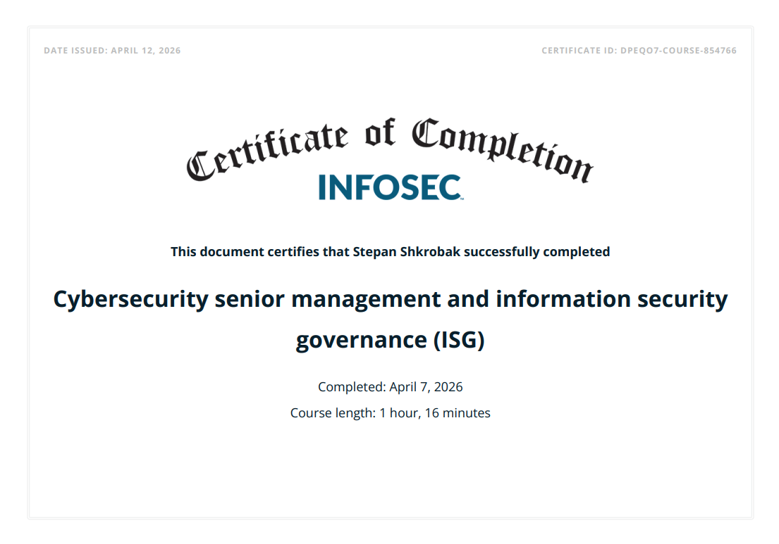

References
National Institute of Standards and Technology. (2024). The NIST Cybersecurity Framework (CSF) 2.0. https://www.nist.gov/cyberframework
ISACA. (2023). COBIT 2019 framework: Governance and management objectives. https://www.isaca.org/resources/cobit
National Institute of Standards and Technology. (2025). Security and privacy controls for information systems and organizations (SP 800-53, Rev. 5, Release 5.2.0). https://csrc.nist.gov/pubs/sp/800/53/r5/final
Center for Internet Security. (2024). CIS Critical Security Controls version 8.1. https://www.cisecurity.org/controls/v8-1

